**Exercise 1: Control Structures**

**Scenario 1:** The bank wants to apply a discount to loan interest rates for customers above 60 years old.

CREATE TABLE Customers (CustomerID NUMBER, Name VARCHAR2(100),Age NUMBER, Balance NUMBER,IsVIP CHAR(1));

CREATE TABLE Loans ( LoanID NUMBER,CustomerID NUMBER,InterestRate NUMBER, DueDate DATE);

INSERT INTO Customers VALUES (1, 'Amita', 65, 15000, 'N');

INSERT INTO Customers VALUES (2, 'Bhavitha', 45, 8000, 'N');

INSERT INTO Customers VALUES (3, 'Shriya', 70, 20000, 'N');

INSERT INTO Customers VALUES (4, 'Priya', 35, 12000, 'N');

INSERT INTO Loans VALUES (101, 1, 7.5, SYSDATE + 10);

INSERT INTO Loans VALUES (102, 2, 6.0, SYSDATE + 40);

INSERT INTO Loans VALUES (103, 3, 8.0, SYSDATE + 25);

INSERT INTO Loans VALUES (104, 4, 6.5, SYSDATE + 5);

* + **Question:** Write a PL/SQL block that loops through all customers, checks their age, and if they are above 60, apply a 1% discount to their current loan interest rates.

BEGIN

FOR cust IN ( SELECT c.CustomerID, l.LoanID, l.InterestRate FROM Customers c JOIN Loans l ON c.CustomerID = l.CustomerID WHERE c.Age > 60)

LOOP

UPDATE Loans

SET InterestRate = InterestRate - 1

WHERE LoanID = cust.LoanID;

DBMS_OUTPUT.PUT_LINE('Discount applied to Loan ID ' || cust.LoanID || ' for Customer ID ' || cust.CustomerID);

END LOOP;

END;

/

**OUTPUT:**

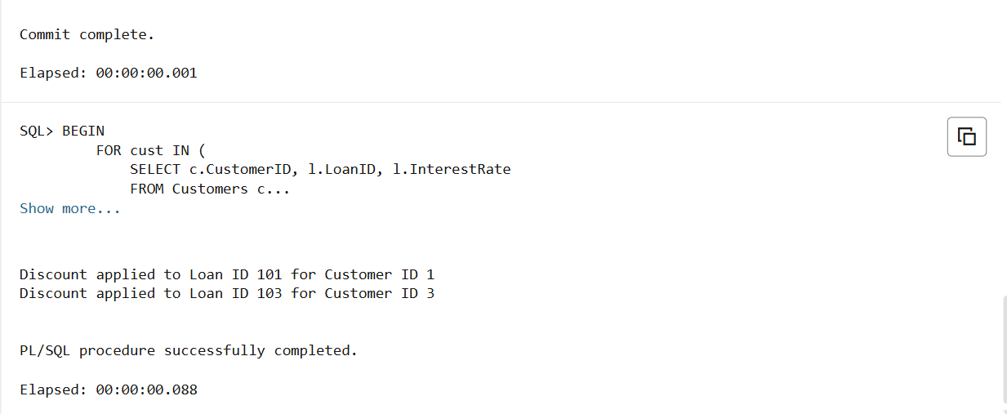

**Scenario 2:** A customer can be promoted to VIP status based on their balance.

* + **Question:** Write a PL/SQL block that iterates through all customers and sets a flag IsVIP to TRUE for those with a balance over $10,000.

BEGIN

FOR cust IN ( SELECT CustomerID, Balance FROM Customers WHERE Balance > 10000 )

LOOP

UPDATE Customers

SET IsVIP = 'Y'

WHERE CustomerID = cust.CustomerID;

DBMS_OUTPUT.PUT_LINE('Customer ID ' || cust.CustomerID || ' promoted to VIP.');

END LOOP;

END;

/

**OUTPUT:**

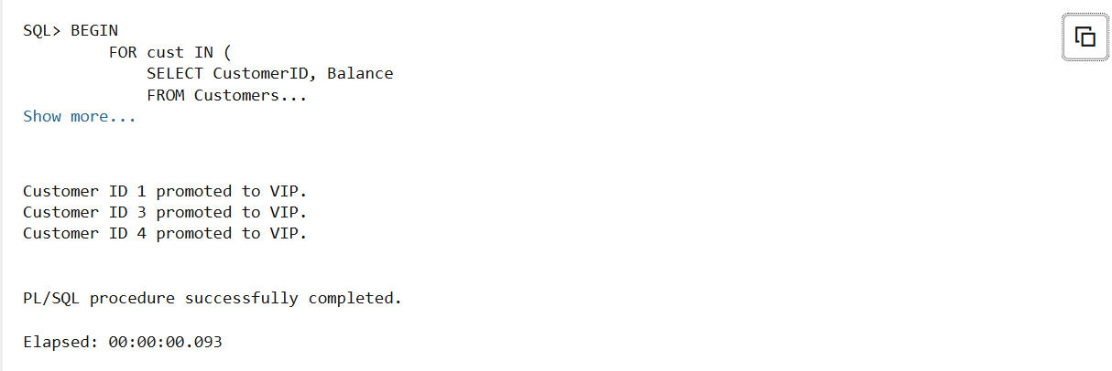

**Scenario 3:** The bank wants to send reminders to customers whose loans are due within the next 30 days.

* + **Question:** Write a PL/SQL block that fetches all loans due in the next 30 days and prints a reminder message for each customer.

BEGIN

FOR loan IN (

SELECT l.LoanID, l.CustomerID, c.Name, l.DueDate FROM Loans l JOIN Customers c ON l.CustomerID = c.CustomerID WHERE l.DueDate BETWEEN SYSDATE AND SYSDATE + 30 )

LOOP

DBMS_OUTPUT.PUT_LINE('Reminder: Loan ID ' || loan.LoanID || ' for Customer ' || loan.Name ||

' is due on ' || TO_CHAR(loan.DueDate, 'DD-Mon-YYYY'));

END LOOP;

END;

/

**OUTPUT:**

